Using map skills to get my A*
1. Four Figure Grid References
1. The camp site below RUGBY | 4775
2. The public house near Bretford | 4377
3. The parking near Bilton | 4972
4. The two Masts near Tythe Fm | 4881
5. What is in the box 4380? | Smite Brook
6. What is in the box 4871? | PH, church and post office
7. What is in the box 4476 | Church Lawford
8. What is in the box 4682? | Pailton Hospital, road
Rules for doing four grid references:

Using the Rugby map find the four figure grid references of the following:

2. Six Figure Grid References
Rules for doing six grid references:

1. The camp site below RUGBY | 475 751
2. The public house near Bretford | 431 771
3. The parking near Bilton | 491 724
4. The two Masts near Tythe Fm | 486 812
5. What is at 442 749? | Deciduous forest
6. What is at 427 826? | Site of monument
7. What is at 492 771? | Public house
8. What is at 498 759? | Wks
3. Directions
Step 1: Basic direction Step 2: Making it a bit more complicated

Step 3: Making it even more complicated…

4. Distance
1. As the crow flies between Rugby camp site and the golf course by Thurlaston.
2. As the crow flies between Heath farm and Clayhill Farm.
3. As the crow flies between Tythe Farm and Little Lawford.
4. As the crow flies between Rugby camp site and the golf course by Thurlaston.
5. As the crow flies between Heath farm and Clayhill Farm.
6. As the crow flies between Tythe Farm and Little Lawford.

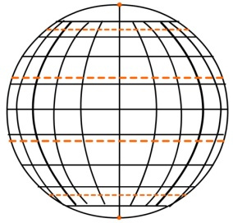
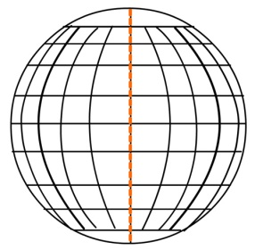
Latitude and Longitude
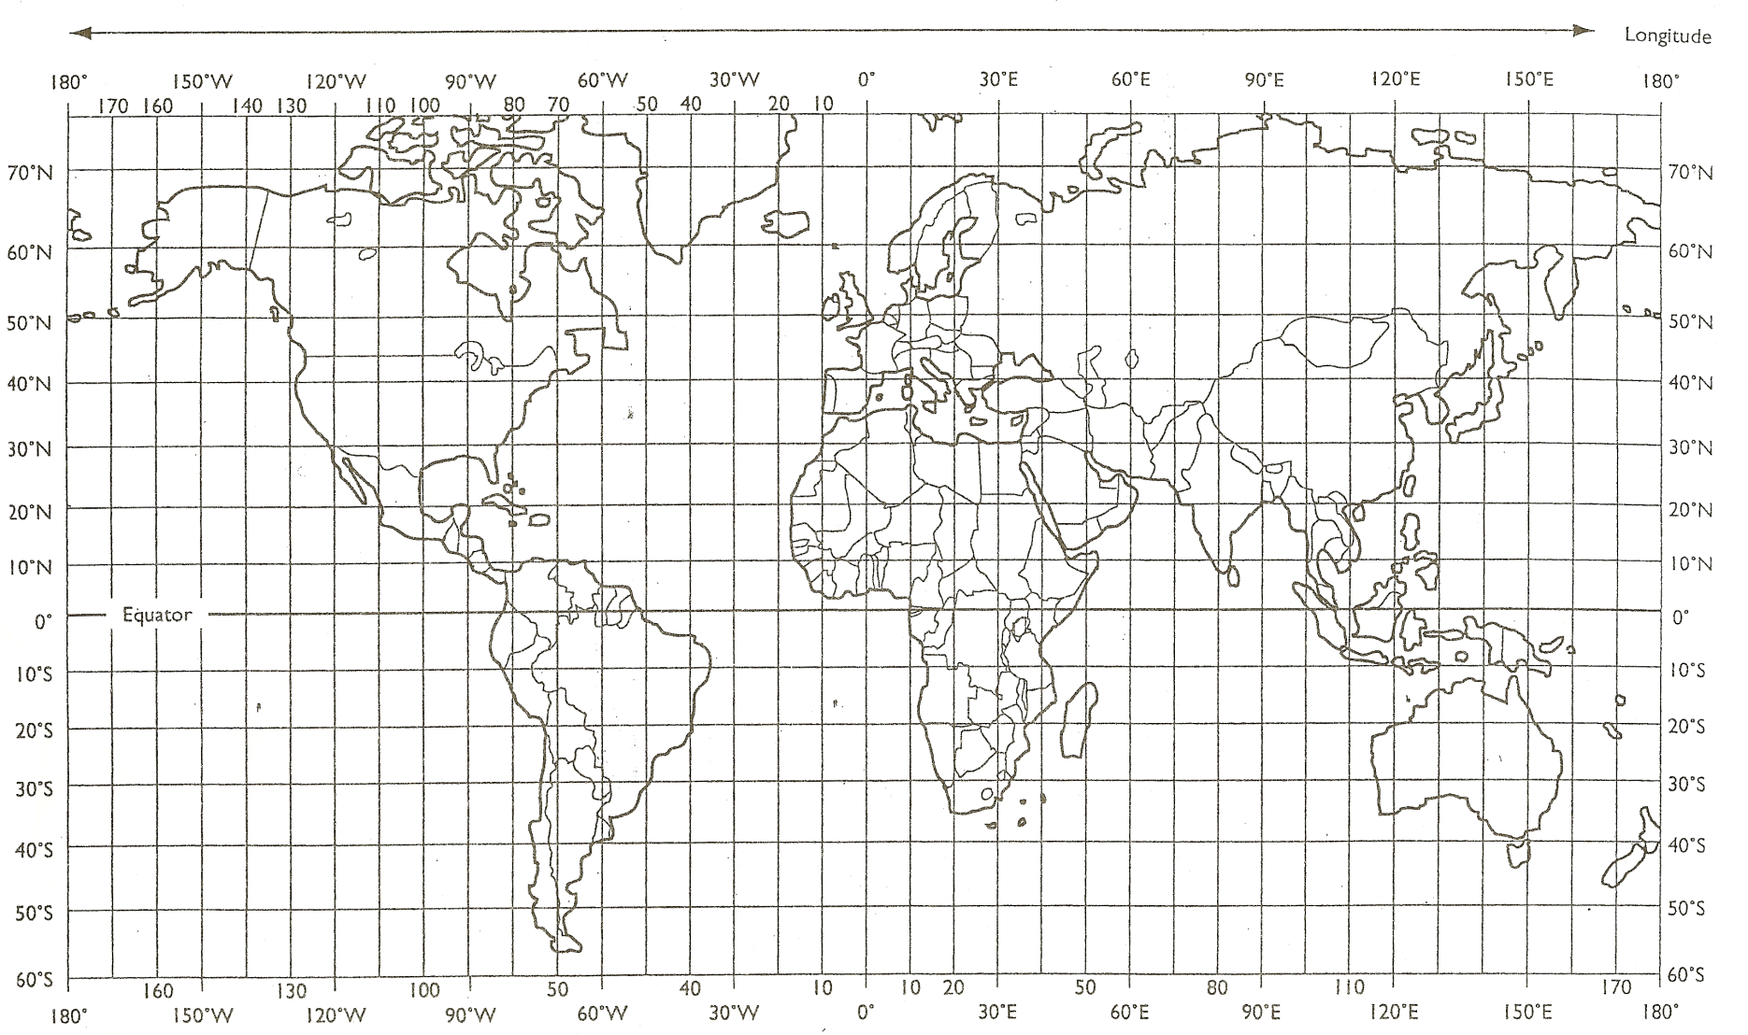
F
E
D
C
B
A

