Revision technique: Mind Mapping

This will work really well for the problem solving paper because we have **NO IDEA** what topic it is on. Therefore you need to know those topics off by heart and back to front.

How to mind map:

1. Start with the theme in the middle of the page.
2. 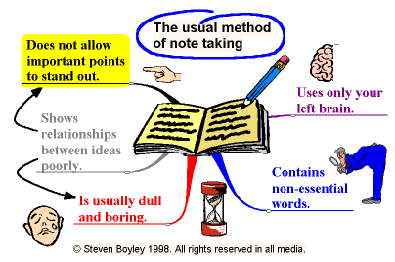Then develop your main idea.
3. Each branch must relate to the branch before it.
4. Use only key words and images.
5. Key words must be written along the branches.
6. Printing your key words makes them more memorable.



1. Use highlighters and coloured markers to colour code branches.
2. Make things stand out on the page so they stand out in your mind. (This doesn’t show up well on a black and whole photocopied booklet! You should use a different colour for each main branch and all its sub-branches)



1. Brainstorm ideas. Be creative.
2. Design images you can relate to which will help you remember key information.